**SAP Business Application Studio Configuration in SAP BTP**

SAP Business Application studio is new tool to develop SAP applications. It is next generation of SAP web IDE tool available on SAP BTP (Business technology platform). Just so you know, SAP BTP is the new name for SAP Cloud Platform.

**SAP BTP Cockpit trial subscription**

SAP provides free subscription for BTP so that developers can explore new or upcoming SAP cloud applications and services. Follow below link, scroll down to the bottom of the page and click on 'Get trail now' to resister for trial account . It will generate a global account and trial subaccount for you.

<https://www.sap.com/canada/products/business-technology-platform/trial.html>

**Enable SAP Business Application Studio subscription**

Go to SAP trial subaccount then click on Service Marketplace on left side in BTP cockpit

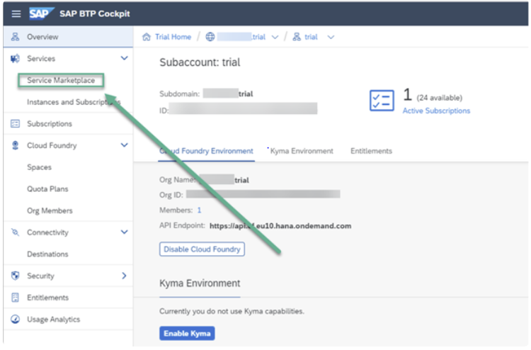

In the search bar, search for studio and then click on Action icon (three dots) to see options. Click **Create** to launch the wizard for subscribing to SAP Business Application Studio.

Select service 'SAP Business Application Studio' and plan 'Trial'. Click on create button to subscribe the application

Now, we can see that we are subscribed to Studio application in the **Instances and Subscriptions** page. From here, we can launch SAP Business Application Studio by clicking 'Go to Application' from three dots right side.

**Create Dev Space**

Enter your credentials and click **Log On**. This will open a welcome page for SAP Business Application Studio. Click on 'Create Dev Space'.

Enter a name for Dev space and select 'SAP Fiori' as the scenario at bottom click on 'Create Dev space'.

Immediately, we can see status is 'STARTING' for this dev space as it takes a few seconds to start.

As soon as the status is 'RUNNING', we are ready to launch Studio application. Click on the name of Dev Space, for example 'Demo_Fiori'.

We are ready to start working on Fiori application development from here.

